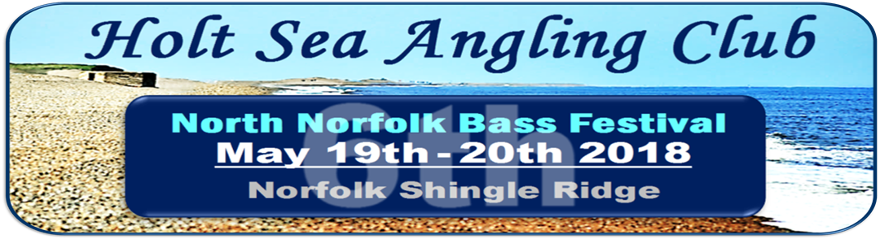
(Some Sponsorship and Support to be confirmed)
In May 2018 Holt Sea Angling club will be hosting the 6th North Norfolk Bass Festival on the shingle ridge in North Norfolk. The inaugural event in 2013 was an outstanding success with over 90 sizeable Bass recorded and released. The 2014 event was as successful although Bass numbers were lower but this was more than compensated by other species. In 2015 a total of 47 bass were recorded and again other species came on strong to create a highly competitive event with 100 match anglers from around the country participating. The 2016 event saw the attendance increase to 106 with 63 Bass being recorded over the two days. In 2017 attendance increased again to 108 with 85 Bass recorded but the event was high jacked by Smooth Hounds with 317 recorded on Day 1 and 27 on Day 2.
The 2018 Festival will again incorporate the UK Ladies Championships and the North Norfolk Juniors Tournament with both being supported by a major UK tackle company and a local business along with the Shannock Quads a “Teams of 4” competition supported by Sheringham Carnival. As last year the event will include a Mystery Pairs competition where all adult competitors will be paired dependent on their Zone positions after the Day 1 match. The Festival will be held over the weekend of May 19th/20th 2018. Holt Sea Angling Club would like to again thank all the various organisations for their help in making this year’s event again possible.
The Bass Festival event will be sponsored by Kelling Heath Holiday Park and supported by Sea Angler Magazine (to be confirmed). The event will comprise of two separate 5 hour matches fished on Saturday 19th May and Sunday 20th May. The provisional venues for the event will be Cley and Kelling on the North Norfolk Shingle Ridge. Each competitor will fish one of these venues on one day and the other the following day. As in previous years, both matches will be on the ebb tide and the exact times of each match will be determined closer to the date and will be identified in an Information Pack which will be sent to each competitor who has booked.
Both matches will be catch & release and fished to Holt SAC match rules.
As in 2017, Holt SAC has agreed that all species will be returned and not taken for consumption for the duration of the event. This means that the Event will comply with any National or EU Legislation regarding Bass as well as promoting the conservation of all other species. Any competitor breaking this ruling will be penalised. This ruling will apply to all the Event competitions.
The entry fee for the Bass Festival will be £20 for each day with an Optional Pools of £10 per day. Prize monies for each match will be for the heaviest bass, heaviest bass bag, heaviest flattie bag (NEW) and heaviest overall bag. There will also be prizes and trophies donated by Kelling Heath Holiday Park for the biggest bass of the festival, day winners and overall winner. Further prize categories will be added if the prize table allows. The competition will be registered for Penn Points.
The UK Ladies Championships will be sponsored by Tronixpro (to be confirmed) and supported by Kelling Heath Holiday Park. The event will follow the same logistical format as the Bass Festival regarding venues and rules, etc. Ladies pegs will not be a separate group but will be incorporated with all the Bass Festival competitors with every fifth or so peg being a Ladies peg. The exact spacing between the ladies pegs will be determined once the final number of ladies is known. There will also be provision for Ladies/Bass Festival double pegs where ladies and partners may fish together in both events. Ladies may also register to fish in both the Ladies and Bass Festival events. Both matches will be catch & release and fished to Holt SAC match rules.
The entry fee for the Ladies event will be £10 for each day with an Optional Pools of £5 per day. Prize monies for each match will be for heaviest bag of all species each day and the Optional Pools will be for section winners. There will also be a rod or reel for the top three ladies over the two days as well as a perpetual shield for the overall Ladies Champion. These have been donated by Tronixpro (to be confirmed) and Holt SAC would like to thank George Cunningham for his support.
The North Norfolk Juniors Tournament will be supported by Country Cars of Cromer. The event will follow the same format as the Ladies event where Juniors will be fishing under real match rules with Junior pegs spaced out equally across the venues. The exact spacing will be determined by the number of Juniors participating. Each Junior MUST be accompanied at all times by an adult who may or may not be fishing the Bass Festival or Ladies events. If the adult is fishing either of these event then double pegs will be assigned.
Entry will be FREE to all Juniors and is open to all Juniors across the country. There will be a perpetual shield donated by Country Cars for the overall Junior winner of the two days and other prizes.
The Shannock Quads is a “Teams of 4” competition supported by Sheringham Carnival. This competition will be based on the total weight recorded by the four team members of each nominated team over the two days and the team with the highest aggregate weight will be declared the winners. In the unlikely result of a tie then total number of fish recorded will be taken into consideration. If numbers allow separate day prizes will be awarded. All Team members must participate in at least one of the other three Festival competitions. Entry will be £20 per team for the full competition. Apart from the monetary payout the winning team will receive a perpetual shield donated by Sheringham Carnival.
As last year there will be a Mystery Pairs competition where adult competitors will be paired dependent on their Zone positions after the Day1 match. The selection process will randomly pair those in the top half positions with those in the bottom half which will make for a fair an interesting final day result. The winners will be determined by the accumulation of the pairs Zone positions over the two days with the lowest scores taking the honours. The fee for this competition is embedded in the Overall fee for the competition and Ladies will be compensated if they fish both the Ladies & Bass Festival competitions. Number of winners will depend on the number of competitors competing. There has been a complaint about competitors automatically being entered in this competition so there is an option on the booking form to be excluded from this competition with a refund of £2 on the daily fee.
The Head Quarters for the event will be Kelling Heath Holiday Park and they will be offering a 15% discount on accommodation for those participating. A short break booking will commence on Friday 18th May and finish on Monday 21st May with rates still extremely competitive for this time of year. Accommodation comprises of Lodges and a large number of Holiday homes which can accommodate up to 6 adults. There are plenty of restaurant and bar facilities at the complex as well as a Leisure Centre. There is also plenty of activity in the surrounding woodland and Kelling Heath is renowned for the amenities it provides. Holt SAC has hosted the last five Festivals and four National Sea League Finals from this location and all have been impressed with the facilities and the general atmosphere.
This is an ideal place to bring your family, partner, etc. for a short break at the start of the summer. They can enjoy the surrounding facilities whilst you can enjoy your sport or alternatively they can join you on the beach which is just 2 to 3 miles away. Check out their website at www.kellingheath.co.uk .
The cost of accommodation with 15% discount for this weekend will be as follows …
- Heron - £254.15 ) Holiday
- Nightjar - £294.95 ) Homes
- Bittern - £300.10 )
- 2 Bed Lodge - £412.25
- 3 Bed Lodge - £449.65
With this event becoming very popular the above assigned accommodation is snapped up very quickly particularly the Holiday Homes. However, Kelling Heath has a sister site on the coast 6 miles away at East Runton called Woodhill Park which also has a number of Holiday Homes at a slightly lower rate than above and they can also be booked through Kelling Heath. In addition, for the more open air and hardy competitors Kelling Heath also has a large number of pitches for tourers and tents. They are offering 3 nights for the price of 2 and these can also be booked as detailed above.
If you require accommodation for the weekend please contact Kelling Heath Holiday Park on 01263 588181. Please note you require to book by phone and not on-line to obtain the discount.
If you require more information please contact Tony Thomas at Holt Sea Angling Club on 07780793141 or thomasamt@btinternet.com. All of this information is also available on Holt SAC’s website, www.holtsac.com under the Open Events option. .
If you and/or your friends are interested in participating in either the Bass Festival, Ladies Championships, Juniors or Shannock Quads competitions then please use the attached booking form. Please note that booking for just one of the matches will be allowed and the final itinerary included in an Information Pack will be mailed to each competitor prior to the event
Booking is required to be made on the Event Booking Form and received along with the identified entry fee(s) by Friday 4th May 2018. Bookings after this date cannot be accepted.

